Ideation Phase

Define the Problem Statements

|  |  |
| --- | --- |
| Date | 19 September 2022 |
| Team ID | PNT2022TMID07316 |
| Project Name | Project –Personal Expense Tracker |
| Maximum Marks | 2 Marks |

**Customer Problem Statement:**

Many businesses use their own system to keep track of their income and expenses because they believe this to be the most important factor in how well their operations are going. It is a good habit to keep track of daily expenses and income, but because people are unaware of the proper applications to protect their privacy and lack the capacity to make decisions, they are still using the old-fashioned note-taking techniques to do so. There is a constant overload to rely on the daily entry of the expenditure and total estimation up until the end of the month because there isn't a complete tracking system.

|  |  |
| --- | --- |
| Who does the problem affect? | Investors, savers, big spenders, debtors,  consumers on a tight budget, and shoppers. |
| What are the boundaries of the problem? | Expense tracking software for employees,  students, and regular people. |
| What is the issue | Being watchful of expenses incurred increases financial strain. Making rash financial decisions could decrease financial security and cause you  to go over your budget. |
| When does this issue occur? | When employing improper budgeting methods. When you don't keep track of your expenses, you can't determine how much was actually  spent. |
| Where is the issue occurring | Working people who struggle to keep track of  their expenses. |
| Why is it important that we fix the problem? | By designating the income for spending, saving, and giving, resolving this problem promotes accountability and encourages financial planning  with purpose. This promotes monetary stability. |

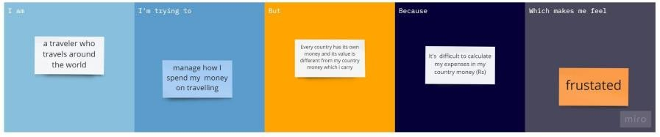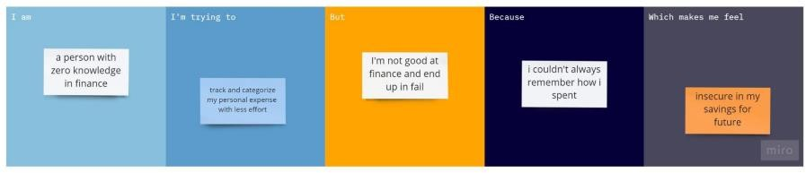

Kevin, who is interested in stock investing, finds it challenging to estimate the cost of stock investing. He can easily and effectively plan out his expenses for investing with the aid of expense tracking.

Raj, a novice budgeter, finds it difficult to keep track of and manage his expenses in the midst of his hectic schedule. Setting priorities for his expenses will enable him to reduce irrational spending.

High school student, Ariyan typically receives a meagre allowance from his parents. So he can spend on both his regular expenses and himself by keeping track of his spending and using good budgeting techniques.

Janet, a shopaholic, struggles to restrain her urge to purchase things. She needs to keep track of her spending and hold herself responsible if she wants to avoid overindulging in impulsive purchases.